
National Data Center
UniVPN Client Installation
NDC UniVPN Client Installation Guideline(for window based workstation)
Classification: Restricted
Bangladesh Computer Council
Information and Communication Technology Division

Content
- Necessary vpn related software and pre-requisite software download link
- Previous Seco-client uninstallation procedure
- For Window based work station UniVPN installation procedure
- UniVPN authentication procedure
- UniVPN user password reset procedure
- Troubleshooting

- Necessary vpn related software and pre-requisite software download link

Pre-requisite Software:
- BCC CA Client
- BCC CA Certificate Installer
- UniVPN-win-full-10781.5.0.0825 (vpn client software)

Required software Download link:
- BCC CA Client: https://www.bcc-ca.gov.bd/media/content/5001
- BCC CA Certificate Installer: https://www.bcc-ca.gov.bd/media/content/10019
- UniVPN Client download links
Windows: https://drive.egovcloud.gov.bd/index.php/s/opN7TJJMjzbGQrq?path=%2FWindows
MAC: https://drive.egovcloud.gov.bd/index.php/s/opN7TJJMjzbGQrq?path=%2FMAC
Linux: https://drive.egovcloud.gov.bd/index.php/s/opN7TJJMjzbGQrq?path=%2FLinux

Instructions:
- Required software must be downloaded and installed in the machine or terminal or laptop from where customer need to access NDC services
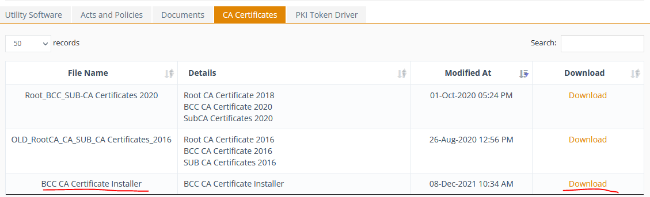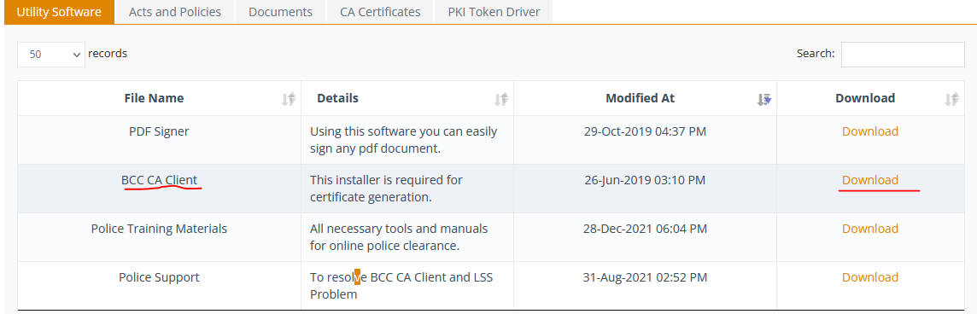
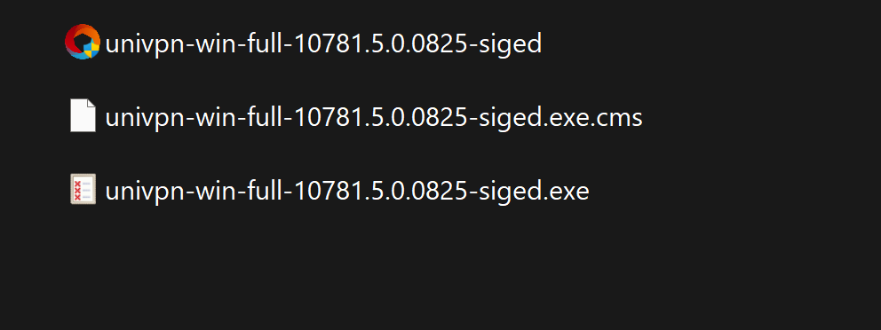

- Previous Seco-client uninstallation procedure

Pre-requisite :
- For NDC existing customer who are using seco(vpn) client need to uninstall the software from workstation
- New NDC customer need to install the UniVPN client in their working terminal
- User must need to install the SSL Certificate in the current local machine

Download the UniVPN installation files in your(customer) local machine(work station) from where you want to access NDC provided services .

After downloading the software from source link and need to extract the zipped files with window operating system default extract software. If the extraction will successful, then in the target location you’ll find the files like below screenshot:

Now need to install the client UniVPN-win-full-10781.5.0.0825-siged setup execution file with windows administrative privileges like below screenshot –

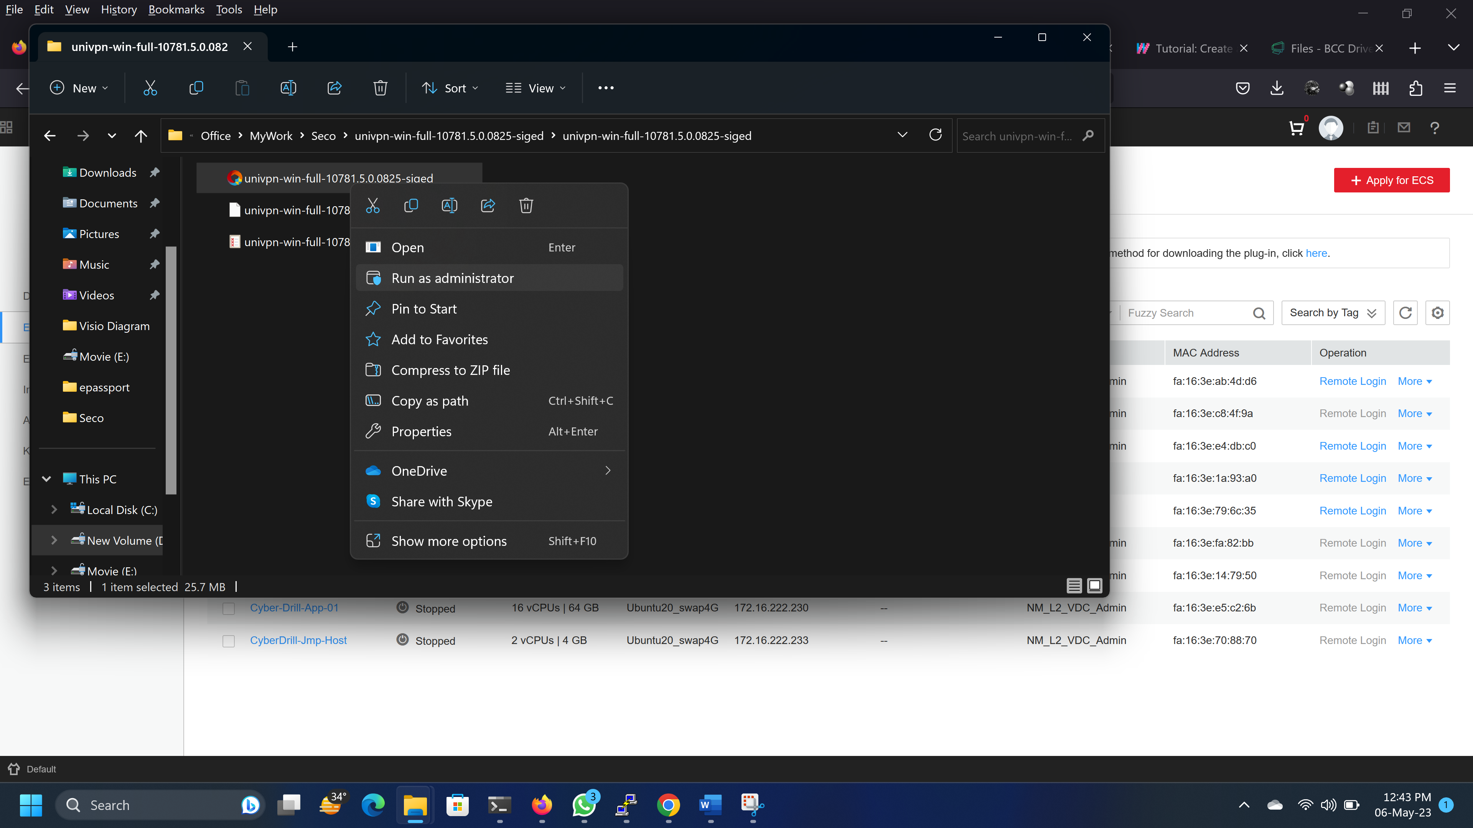

From the below dialog box click Install button to keep forward the installation procedure
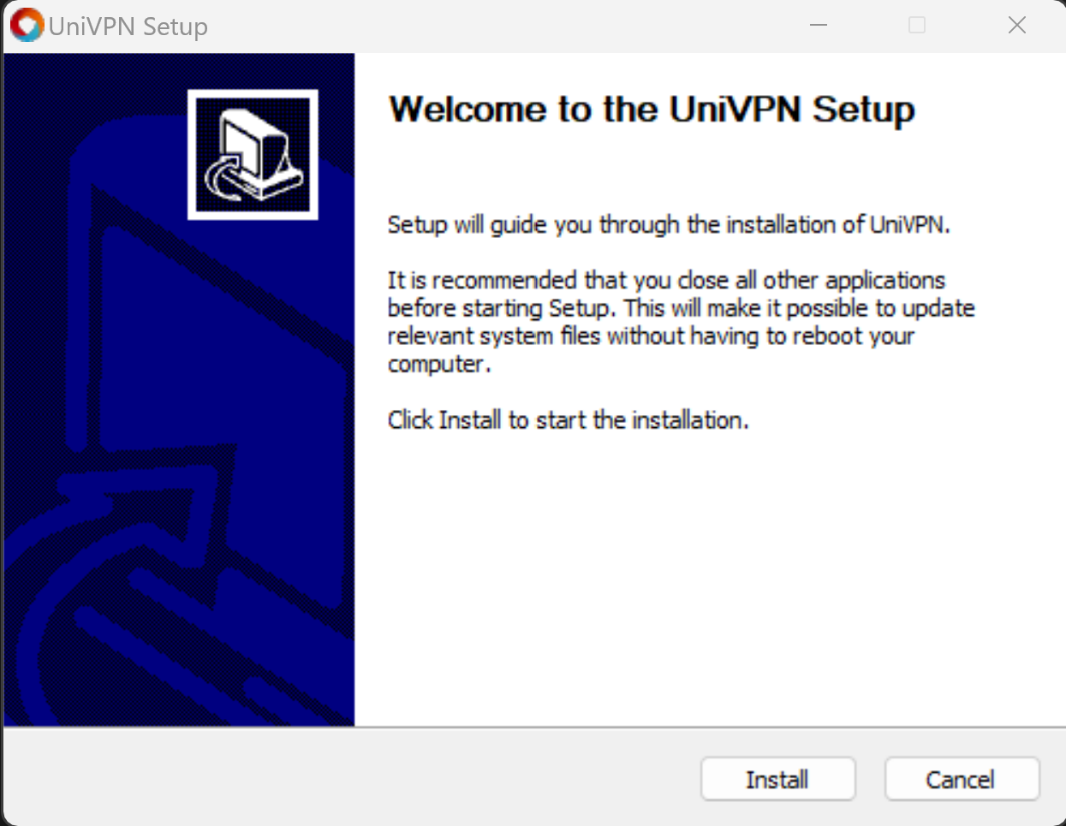
After clicking Install button , software itself will process(as UniVPN detects a SecoClient in your local machine) to uninstall the existing Seco client .
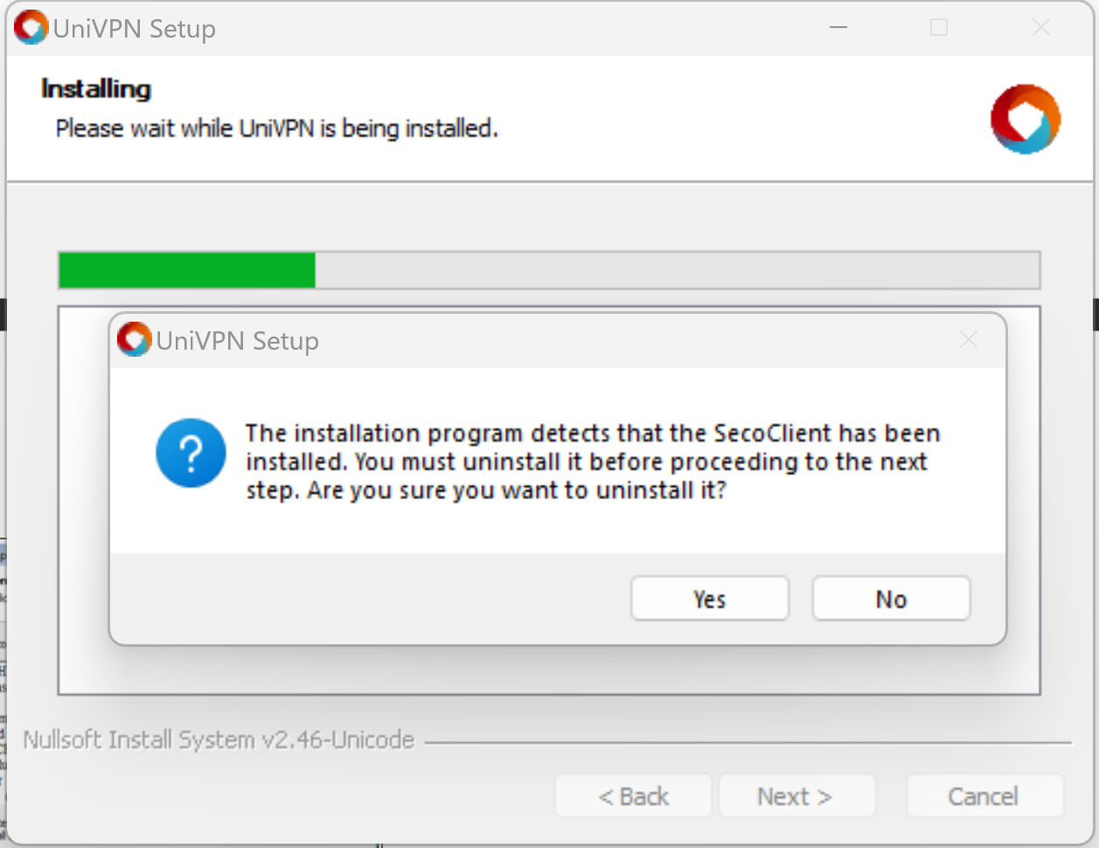

During uninstall procedure it’ll detect the SecoClient is in running state and the process itself will take initiative to stop the existing SecoClient process. The process will take confirmation to uninstall the SecoClient from your local machine.
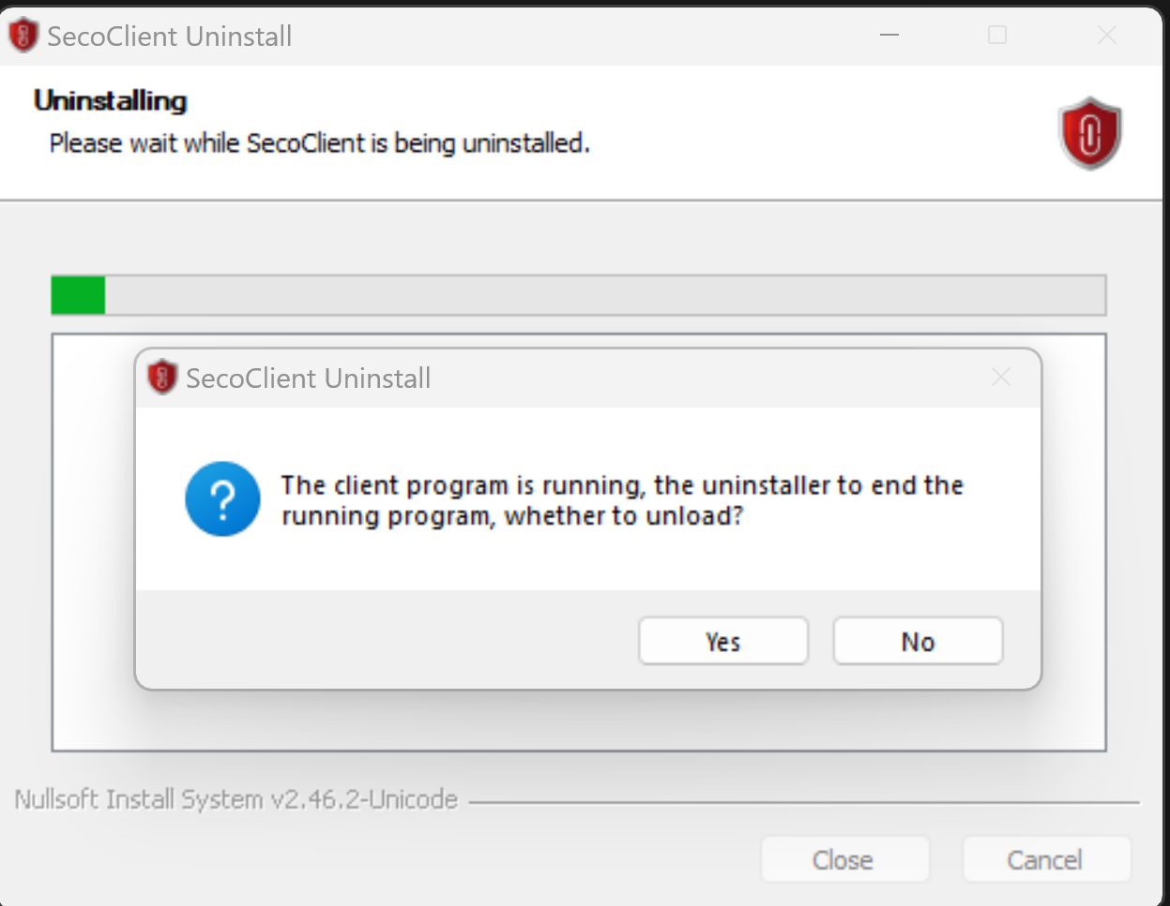
Please press Yes button to provide confirmation to remove all components of SecoClient from your local machine to initiate uninstall procedure.
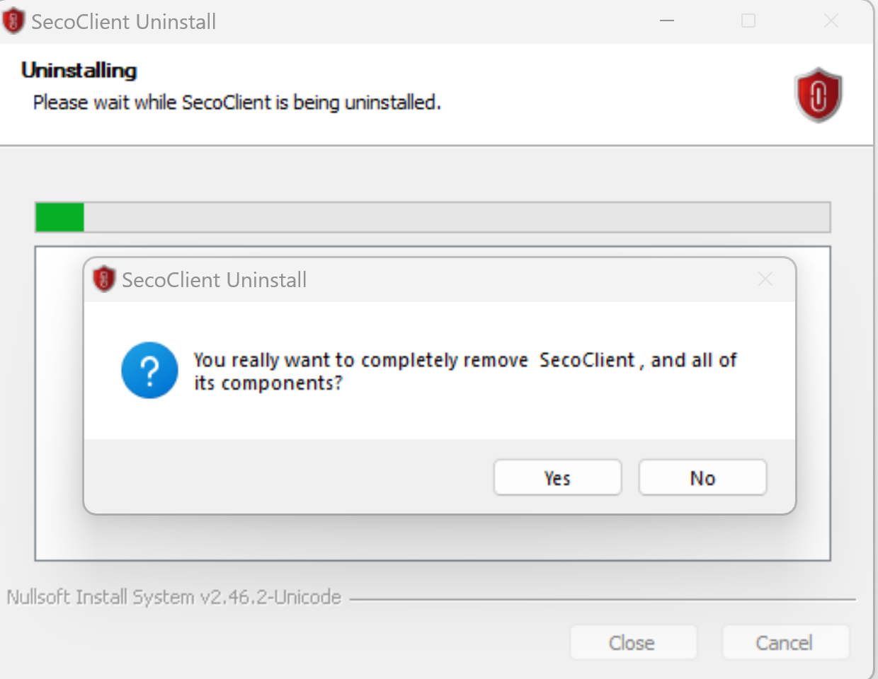
After getting confirmation the process will start to uninstall the programs which are installed during SecoClient installation.
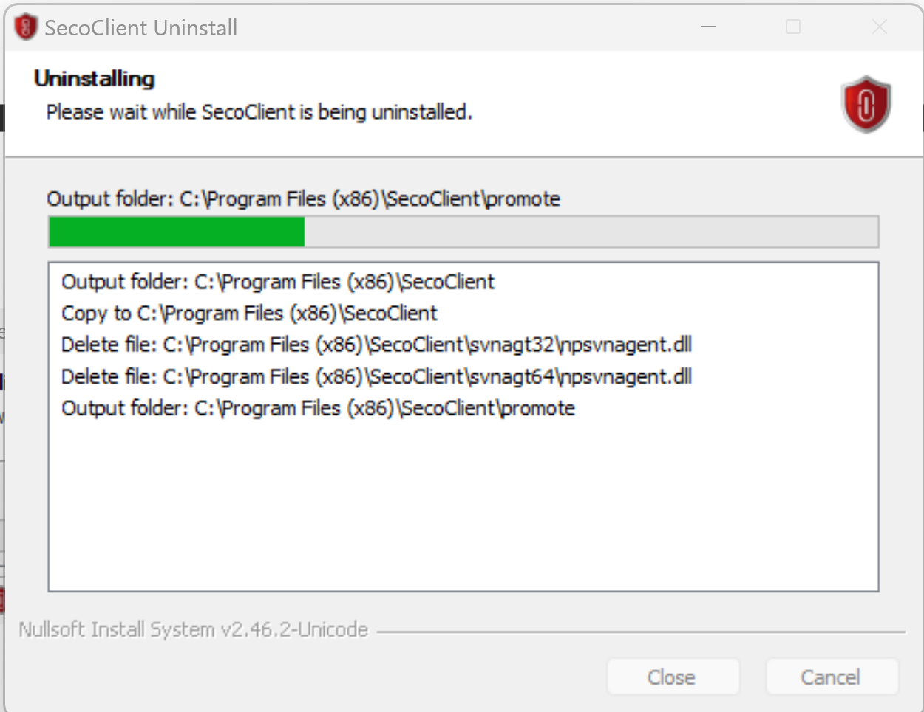
During the uninstall the procedure it will pop-up message to uninstall the virtual NIC driver to finish uninstall procedure and you need to press Yes button to provide permission to remove virtual NIC driver.
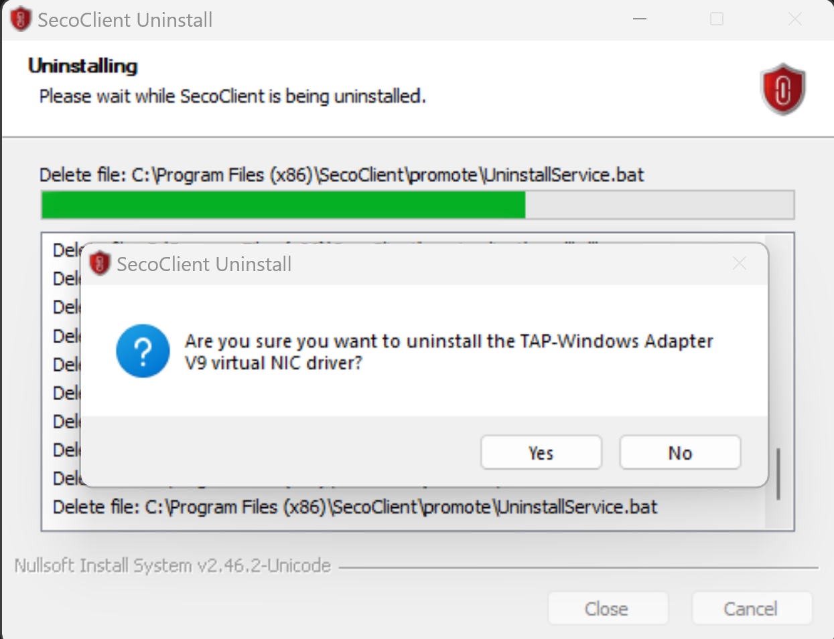
To finish the uninstallation procedure, it’ll ask customer to delete all user configuration of SecoClient.
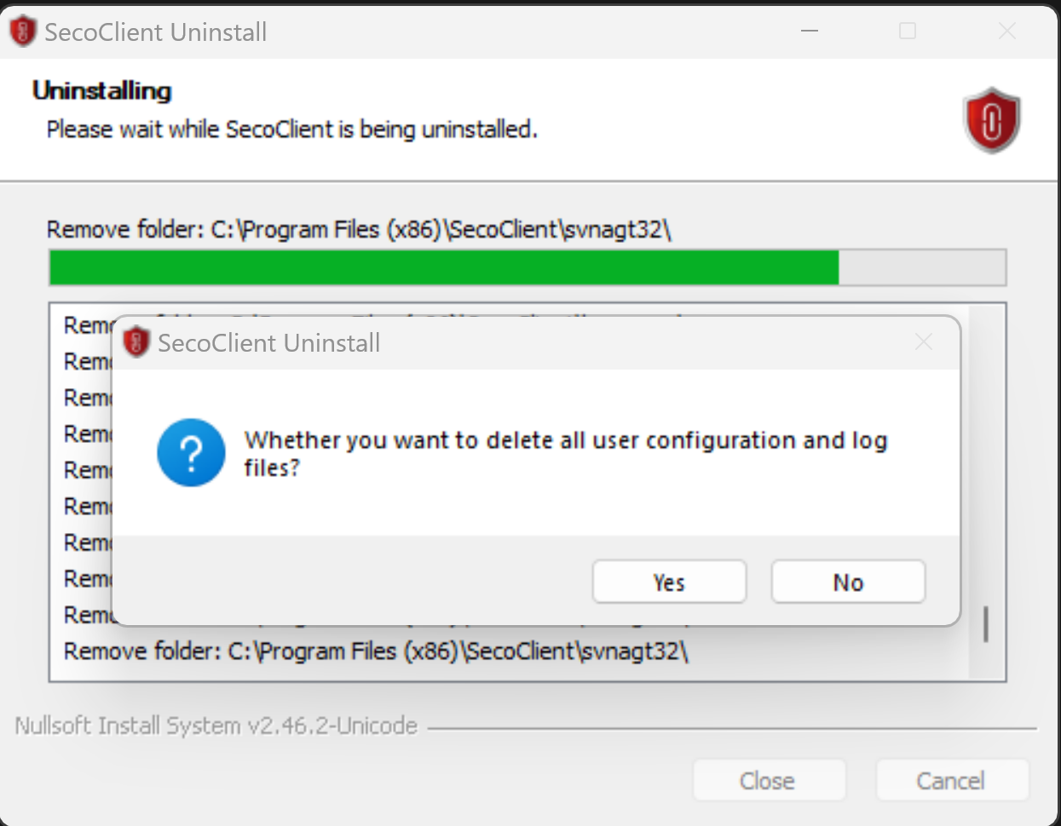
We need to press Yes button to finish the uninstall procedure. After successfully finished SecoClient uninstallation the process will confirm you like below screenshot .
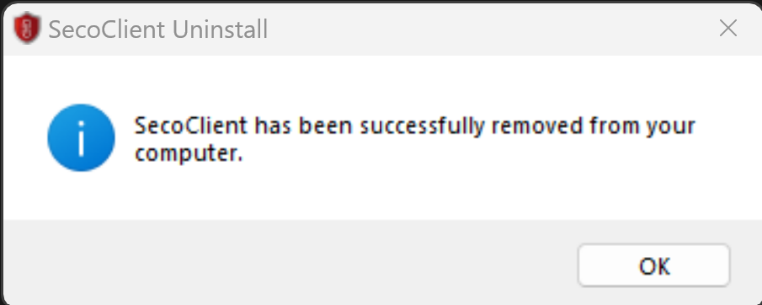
Which means the previous installed vpn software SecoClient has been successfully removed from your local machine. For more confirmation you need to reboot your local machine in this state.

- For Window based work station UniVPN installation procedure

Pre-requisite :
- For NDC existing customer can install UniVPN after successfully remove previous vpn client
- New NDC customer need to install the UniVPN client in their working terminal
- User must need to install the SSL Certificate in the current local machine
- After getting NDC vpn credentials from NDC VPN team , user need to install UniVPNClient.

Download the UniVPN installation files in your(customer) local machine(work station) from where you want to access NDC provided services. After downloading the software from source link and need to extract the zipped files with window operating system default extract software. If the extraction will successful, then in the target location you’ll find the files like below screenshot:
Now need to install the client UniVPN-win-full-10781.5.0.0825-siged setup execution file with windows administrative privileges like below screenshot –
From the below dialog box click Install button to keep forward the installation procedure
Below screenshot is the progress of supporting file installation for UniVPN Client installation
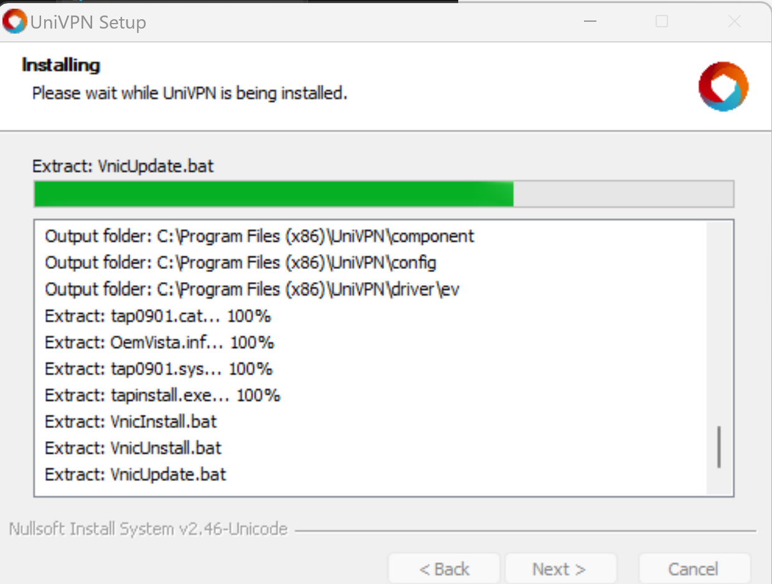
During installation this new UniVPN Client will install a virtual NIC driver for client software like below scrrenshot. So click Install button to proceed to install the virtual NIC driver.
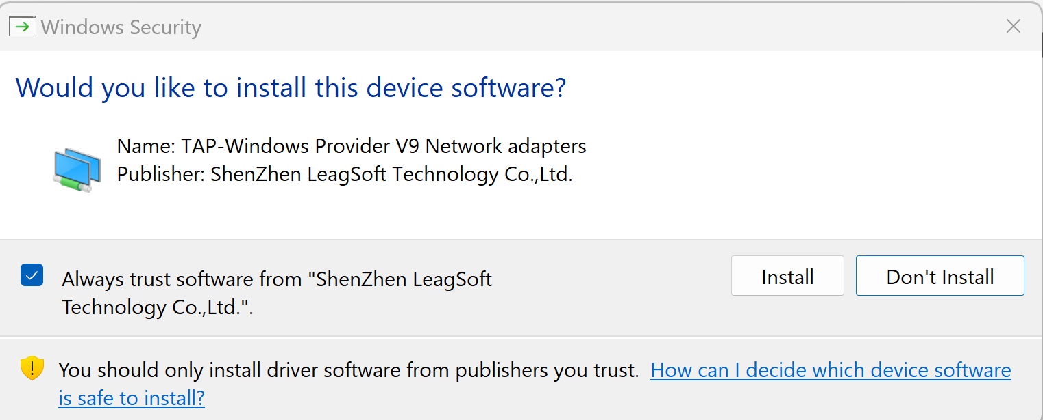
After finishing installation it’ll notify the customer about setup complete message.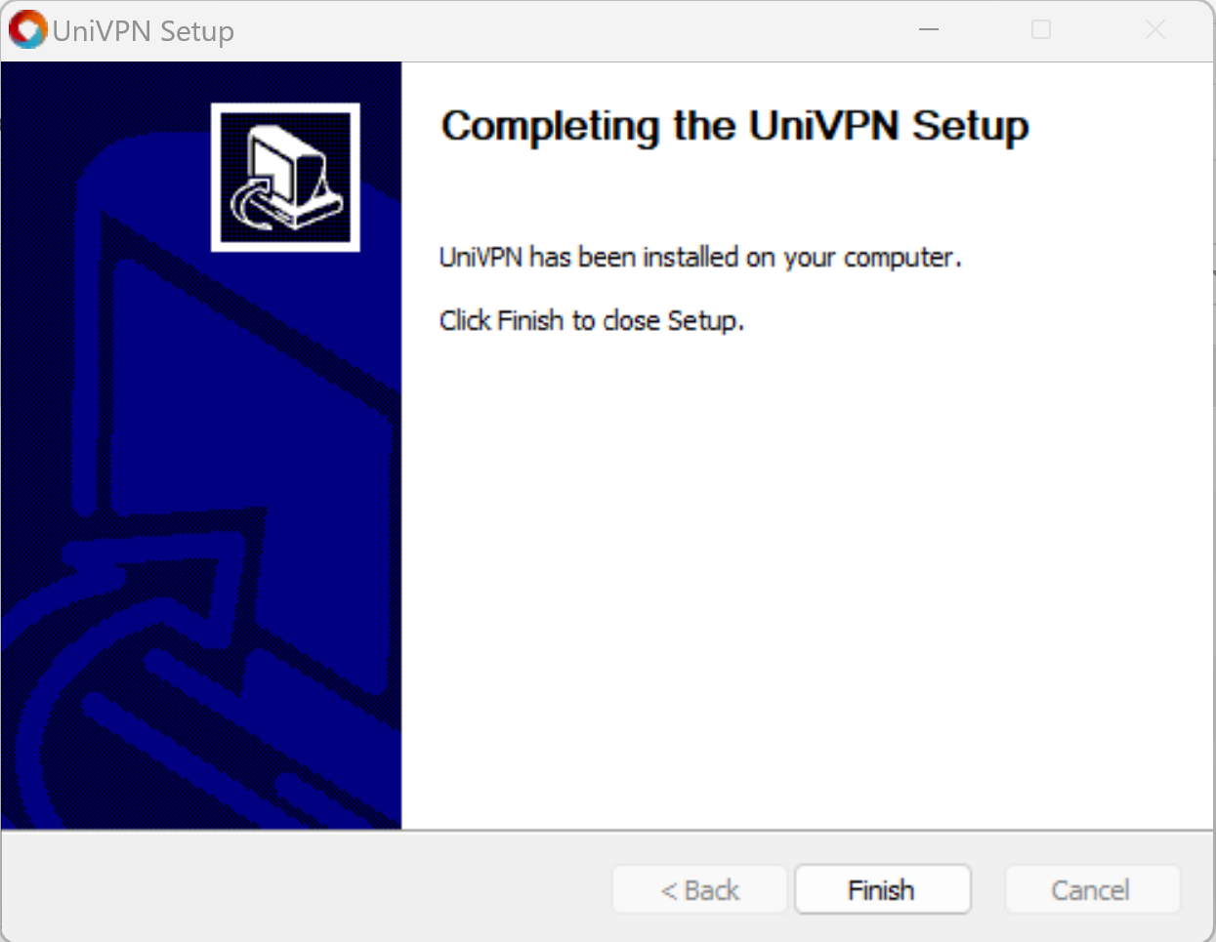
Click the Finish button to complete the UniVPN installation procedure.

- UniVPN authentication procedure

Pre-requisite :
- Must installed UniVPN Client in customer local machine where customer has imported or installed SSL certificate Class-II type for authentication. To install SSL certificate customer can follow SSL Subscription_bangla-v2.0.docx
- Existing NDC customer must uninstall the SecoClient as per Uninstall procedure
- To get NDC VPN credentials customer need to fill up the ssl-vpn-customer-formv2.0.pdf file and mail to datacenter@bcc.gov.bd .

After installation open the new installed UniVPN Client from desktop shortcut button or program files.
> univpn>Open
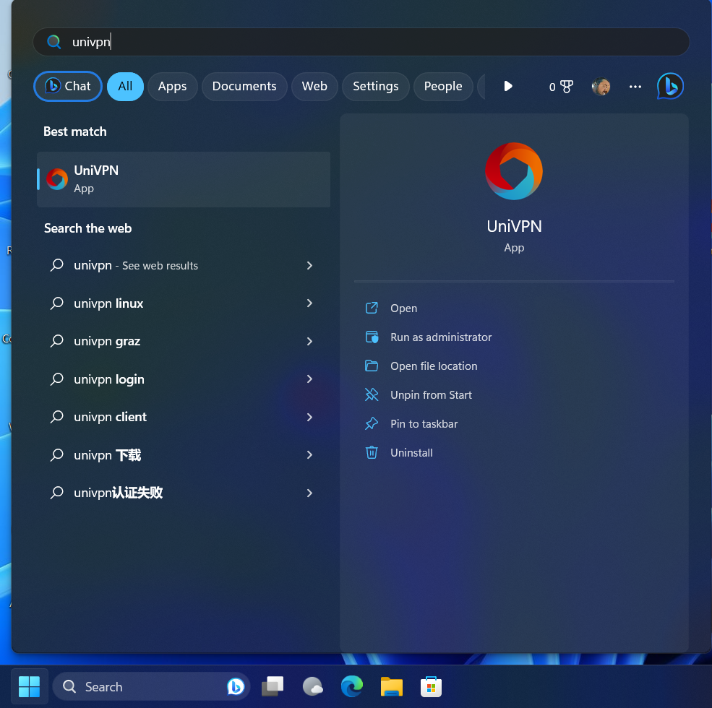
After opening the UniVPN Client need to configure NDC VPN gateway and others necessary configuration in the new UniVPN Client.
So like below screenshot of the UniVPN Client, need to click add New Connection to configure new NDC VPN gateway
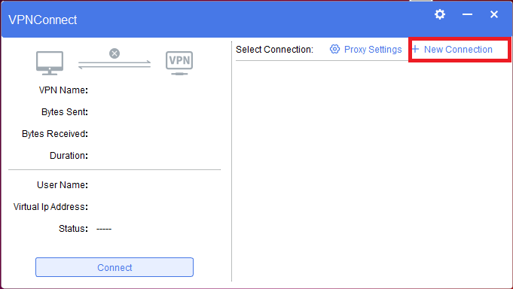

In the new blank dialog box (below screenshot), Need to fill below information with the provided info
Connection Name: BCC_CUSTOMER_VPN
Description: BCC_CUSTOMER_VPN
Gateway Address *: customer-vpn.bcc.gov.bd
Port *: 443
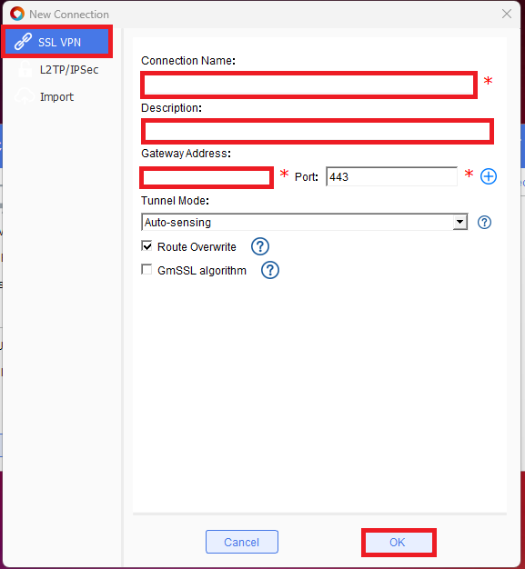
Note Gateway address for BCC partner is partner-vpn.bcc.gov.bd . This gateway is not valid for BCC or NDC Customer.
After filling the new connection with the above provided information need to confirm the configuration by clicking OK.
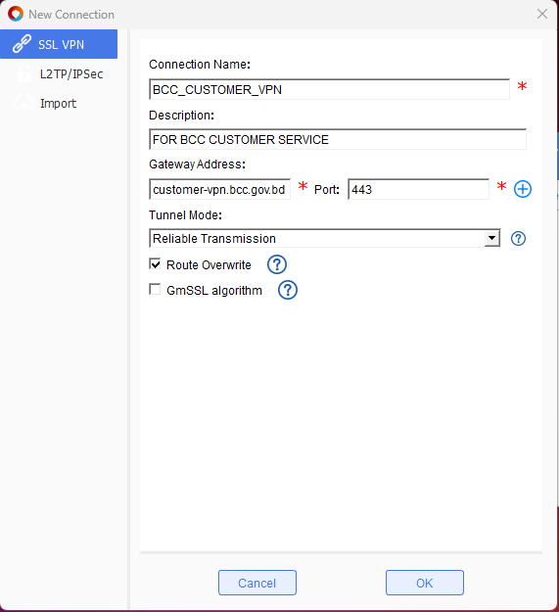

Now the UniVPN configuration will be like below snapshot and click Connect to establish secure connection for authentication
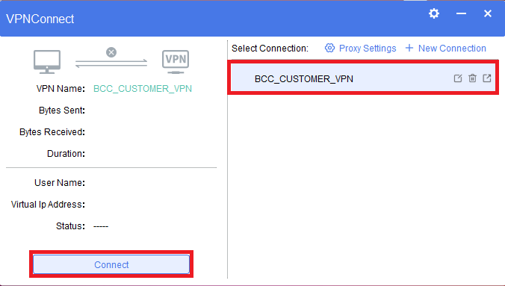
In the authentication area you(customer)’ll get Certificate Name and input the password which is provided by NDC Network or VPN team. After inputting the password please click Login button.
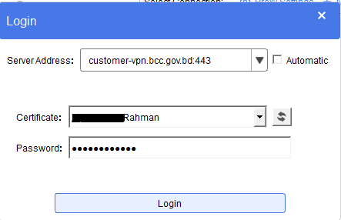
During Login it’ll appear a warning message (below screenshot) which you need to configure by clicking Change Setting to configure Basic Settings
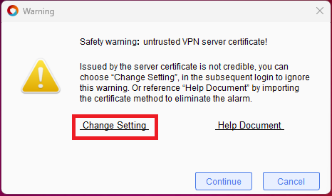
In the Basic Settings Area need to select (UI Language: English Verify trusted servers: mark Open , Detect a new version: mark Open)
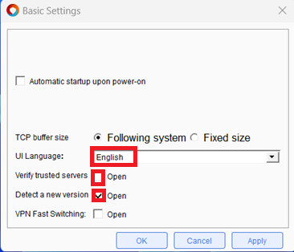
After selecting necessary parameter as mentioned above recommendation Click Apply and OK.
As the warning has been already set with mentioned parameter we can press Continue button in the Warning dialog box.
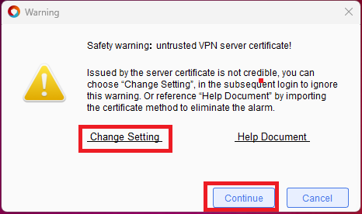
After establishing vpn connectivity a successful message will appear above taskbar.
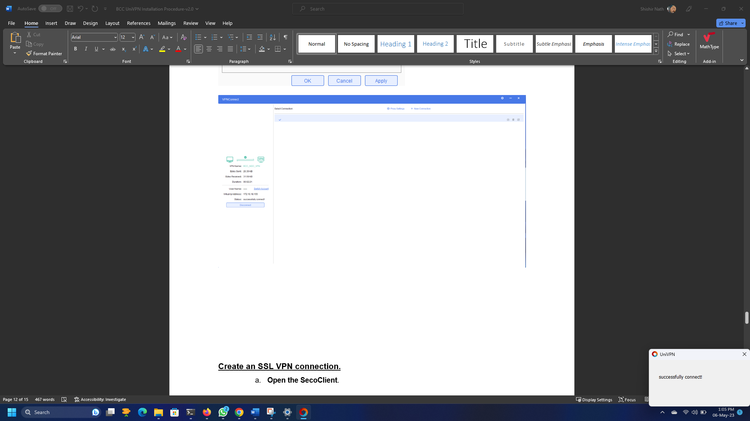
In the taskbar UniVPN Client icon will appear .
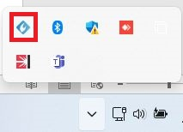

- UniVPN user password reset procedure

Pre-requisite:
- Must remember the vpn user password which is provided NDC VPN team
- New Password and Confirm Password character should same character and same length

From the taskbar right click to UniVPN Client icon below dialog box will appear . From there you(customer) can your default password by Clicking Change Password option.
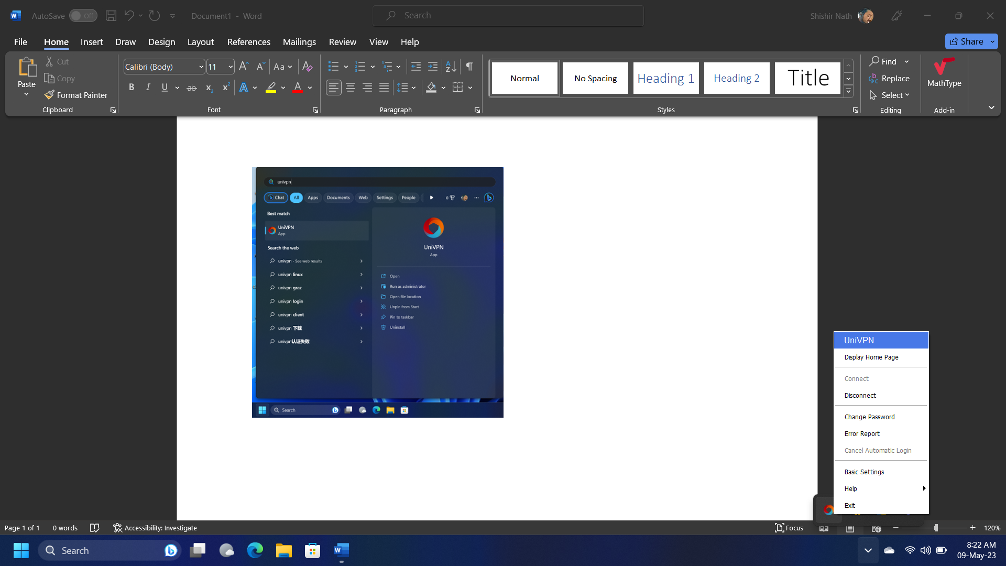
Or you can open the Display Home Page and VPNConnect below page will appear. From the page by clicking settings button you can also get option to change NDC vpn user password.
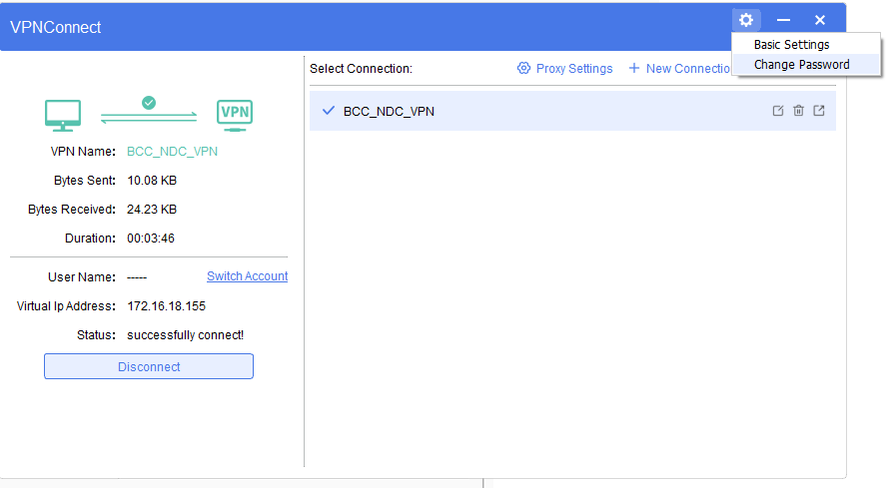

After selecting Change Password option below Change Password dialog box will appear. In Change Password option need to input the Original Password field with NDC provided vpn password. After that in New Password option need to input a new password which you want to set for your vpn account by yourself. During inputting or setting New Password you’ve to maintain proper password Complexity like below hint -
Capital Letter: A to Z
Small Letter: a to z
Special Character: !@!#$%^&*> () <
Password Length: at least 9 or above characters
Now need to inputting Confirm Password. After fill-up the below fields need to confirm by clicking OK button.
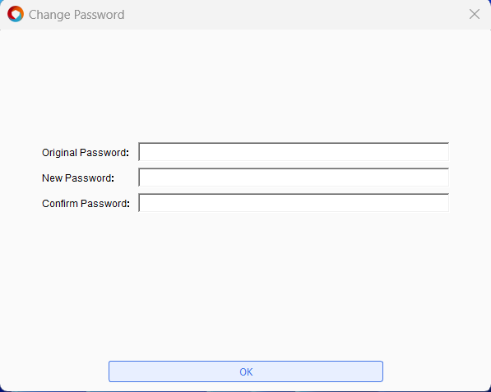

- Troubleshooting

Step -1 . press windows button+R from your keyboard button
Step -2 . then type certmgr.msc command and press enter like below screenshot
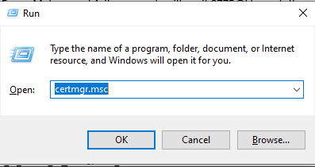
Step -3 . in the Certificates –Current User dialog box , select Personal and check your certificate name which is issued by BCC CA team
